FARNHAM IS CELEBRATING 125 GREAT YEARS
COMMEMORATIVE T-SHIRTS AND SWEATSHIRTS
ORDER FORM
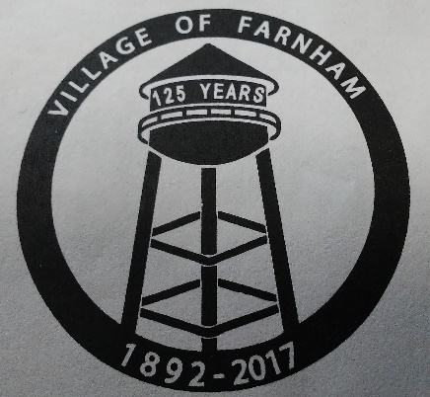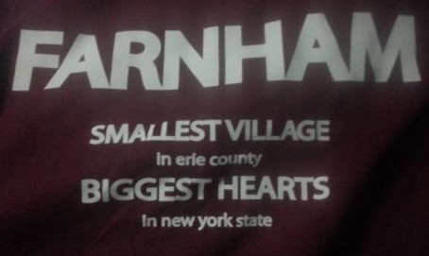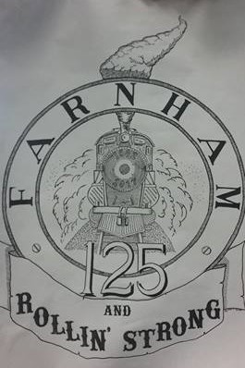
Farnham Crest Back of shirt Railroad

T-SHIRTS
COST: $15.00 (add $2.50 for 2xl & up)
AVAILABLE COLORS:
NAVY, RED, FOREST GREEN, CHARCOAL, ORANGE, TEAL, HOT PINK

SWEATSHIRTS:
COST: $20.00 (add $2.50 for 2xl & up)
RED, NAVY, FOREST GREEN AND CHARCOAL

AVAILABLE SIZES FOR BOTH
YOUTH: SM – XL MENS: SM – 5XL LADIES: SM – 3XL

NAME ____________________________________________ PHONE ________________________

ADDRESS ________________________________________________________________________

YOUTH – Y  MENS – M  LADIES - L | SIZE | T-SHIRT | SWEATSHIRT | COLOR | RAILROAD | CREST

AMOUNT ENCLOSED $_________________ MAKE CHECKS PAYABLE TO: JEFFERSON THOMAS

MAIL OR DROP OFF TO:
VILLAGE TOWN HALL
526 COMMERCIAL ST
PO BOX A16
FARNHAM NY 14061
ATTN: DOLLY

